St. Francis Institute of Technology, Mumbai-400 103

**Department Of Information Technology**

A.Y. 2024-2025

Class: TE-ITA/B, Semester: VI

Subject: **Business Intelligence Lab**

**Experiment – 8: To implement Apriori Association mining algorithm using open source tool WEKA and ORANGE**

1. **Aim:** Implementation of Association in Data Mining (Apriori,FPM) in WEKA & Orange
2. **Objectives:** After study of this experiment, the students will be able to implement Apriori Algorithm in WEKA/Orange
3. **Outcomes:** After study of this experiment, the students will be able to

**CO 5:** Design and Implement various frequent data mining techniques and formulate association rules   on large data sets

1. **Prerequisite:** Introduction to algorithms of Associativity
2. **Requirements:** Personal Computer, Windows XP operating system/Windows 7, Internet Connection, Microsoft Word, WEKA tool, Orange tool.
3. **Theory:**
4. Introduction to FPM
5. Introduction to Apriori Algorithm
6. **Laboratory Exercise:** Implementation of Association Algorithm in WEKA & Orange and take printout of implementation along with coding and snapshot.
7. **Post-Experiments Exercise**
8. **Questions:**
   * Solve numerical for Apriori algorithm
   * Simple CLI execution of Apriori algorithm in WEKA using the following command:

**java weka.associations.Apriori -N 100 -T 1 -C 1.5 -D 0.05 -U 1.0 -M 0.1 -S -1.0 -I -t directory-path\bank-data-final.arff**

1. **Conclusion:**
   * Summary of Experiment
   * Importance of Experiment
   * Application of Experiment

| Loading the dataset in WEKA | Applying Apriori algorithm with minimum rules as 10. |
| --- | --- |
| Output of Apriori algorithm | Setting the number of rules to 100. |

| Result of Apriori with 100 rules | Using Simple CLI to insert command |
| --- | --- |
| Getting 100 rules using CLI | **ORANGE:**  **1. Applying association in Orange:** |

**2. Loading the dataset in Orange.**

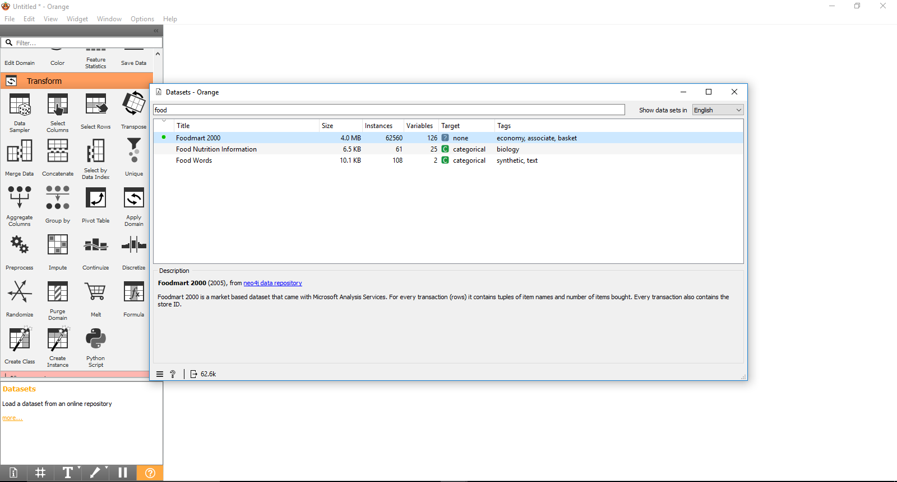

**3. Transaction dataset visible in the dataset widget:**

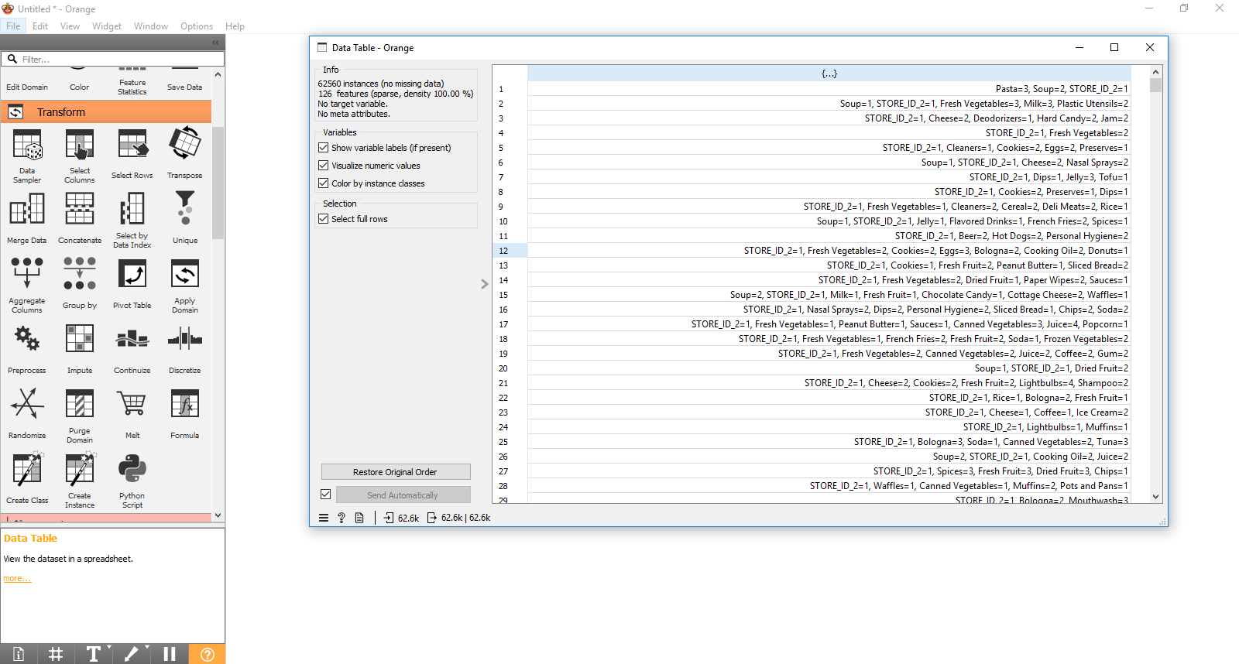

**4. Generating frequent itemsets with min_support=0.01**

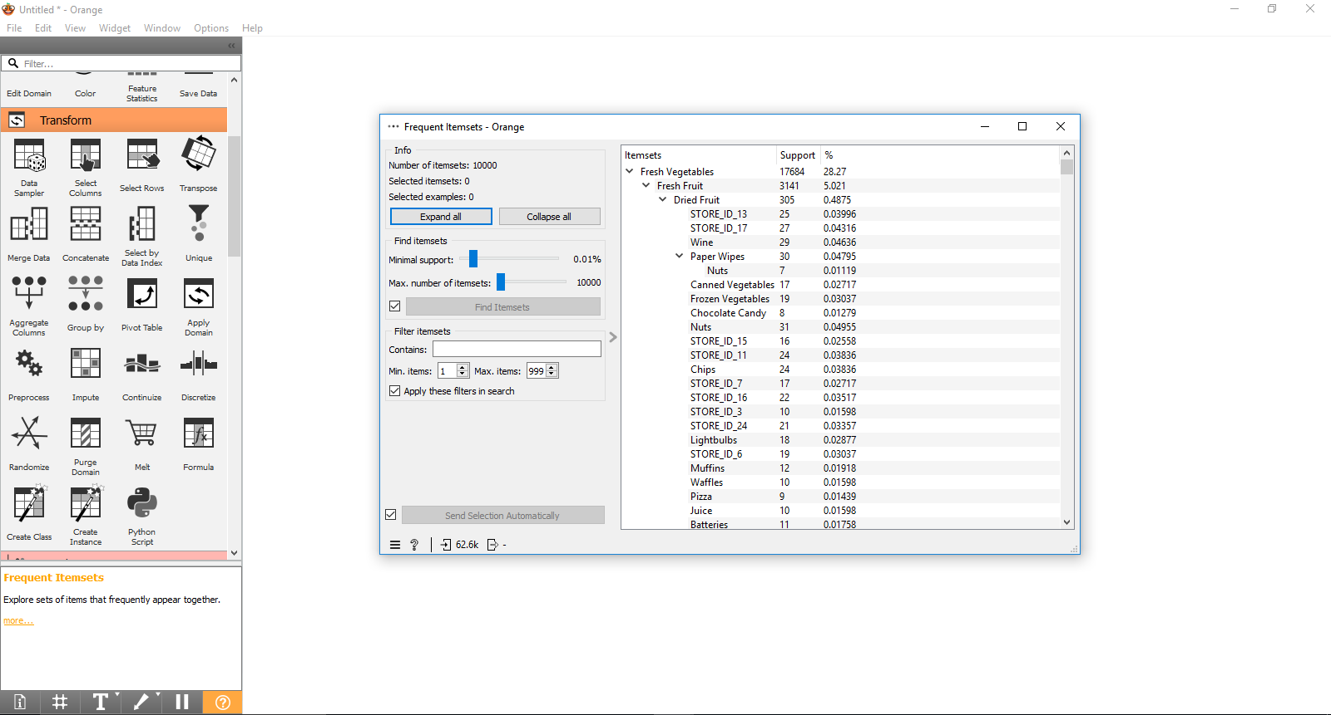

**5. Generating association rules in ORANGE**

